materials of the new short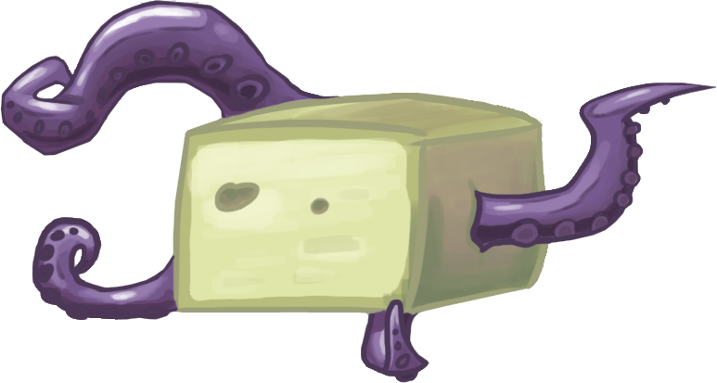
thx digits for this awesome awkward art
Your names on chat won’t be visible to others. Login to gmail
i love you all

15 Minute Short
Warning: Some stuff here might be scrapped.
Scenes:
1. Restaurant
2. Gym
3. Spy’s apartment
other unknown places...

Scenes 2:
1. Date
2. Loaf Monster
3. Heavy Strawberry
4. “I love you too”
5. Pauling getting eaten by loaf monster or falling with a bomb, pull me up scene
6. Engineer examining the loaf scene
7. Administrator yelling, missing pauling
8. Intelligence?
9. Team doing experiments, busy on something.
10. Spy seduce me scenes

Order is random

Some File Names Used:
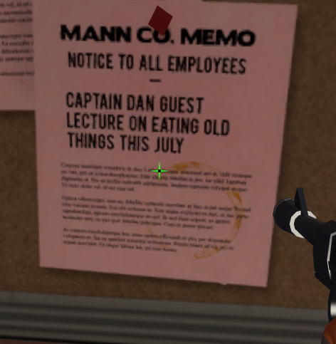
Sheet
Bot Fem
Glass
Bread Knife
Bucket
Candy Box
Cards
Chicken Bucket
Balloon Blue, White
Fish blue, green, yellow
Seaweed
Self Destruct Sign
Dinner Table
Earpiece
Flowers (One, Two, Three)
Boxing Ring
Punch Bag
Weights
Hat Stand
Ice Sculpture
Lecture Valley LOAFS R SAFE K?
Leather
Loaf Mini
Loaf Monster
Loaf Monster Interior
Loaf Tumor
Dapper Cadaver Magazine
Mirror Ball
Self Destruct Console
It's just bread-
It's just bread that grows tumors!
Simple Chair
Bookshelf
Carpet
Corner Panel
End Table
Fireplace

Globe
Liquor Cabinet
Painting
Spy Apartment
Spy Curtains
Storefront
Strawberries
Streamers
Tumbler
Urinal
Wine Bottle

Story
Engie doing an experiment, scene about administrator. Spy asking scout if he is a virgin and teaches how to get woman. They both become magnificent. Scout dresses up like a gentleman and asks pauling out. Pauling asks if scout is having prom (such a bitch) (something happens). They go out on a date and action scenes start. Loaf from lecture valley turns into a monster with tentacles.
SOMEONE, OR SELF DESTRUCT DESTROYS THE MONSTER AND SAVES THE DAY.
Scout does something brave?

Soldier does the final speech

Story is not fully confirmed. It’s speculation. There are more stuff but it’s hard to connect them with story.
Read lecture valley page to see why bread turns into a monster.

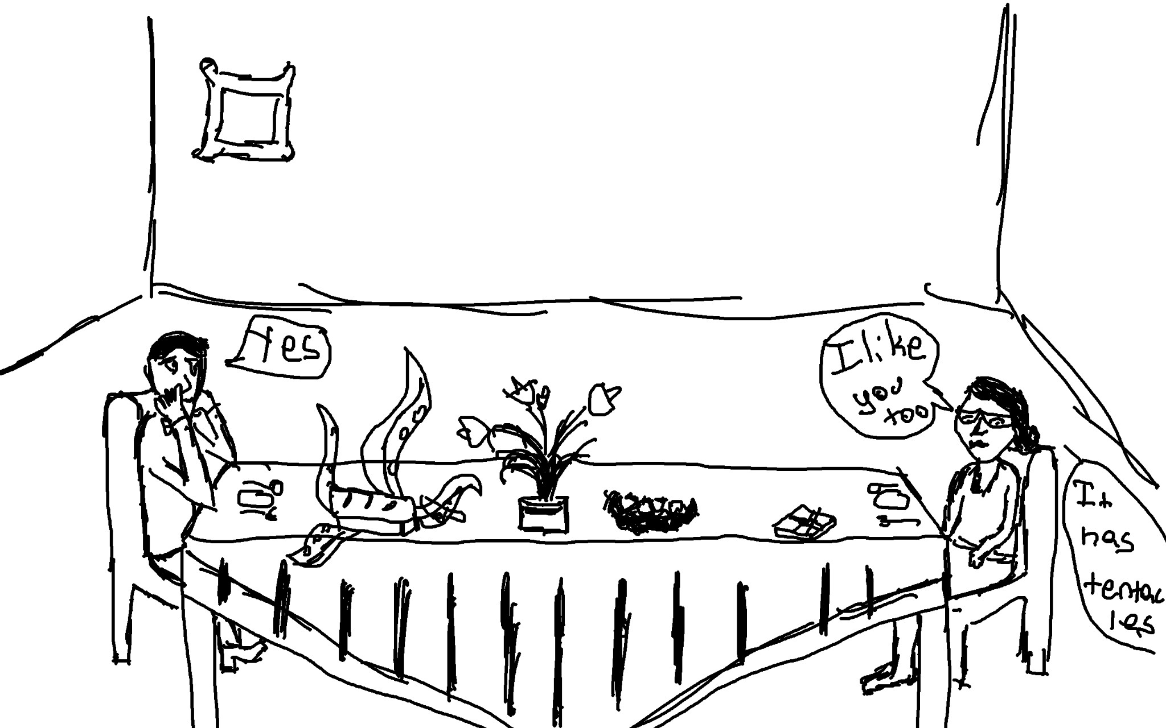

Scout & Pauling 2013 - Forever

Extra stuff:
SFM sound line leak thing organized.

scene01_engie_stress_to_all_of_you.wav
scene01_pauling_bury_details_01.wav
scene01_pauling_later_scout_various.wav
scene01_pauling_nobody_saw_you_01.wav
scene01_pauling_whatever_01.wav
scene01_pauling_you_cant_just_alt.wav
scene01_scout_before_you_go_01.wav
scene01_scout_do_this_next_time_01.wav
scene01_scout_go_to_hell_spy_01.wav
scene01_scout_lookit_all_this_01.wav
scene01_scout_lotta_people_busy_01.wav
scene01_scout_nice_catch_01.wav
scene01_scout_probably_real_busy_01.wav
scene01_scout_uhhhh_01.wav
scene01_scout_were_both_busy_01.wav
scene01_spy_how_long_01.wav
scene01a_admin_miss_pauling.wav
scene01a_admin_miss_pauling_big.wav
scene01a_heavy_goodbye_miss_pauling.wav
scene01a_heavy_grunt.wav
scene01a_pauling_administrators_called_me.wav
scene01a_pauling_and_nobody_saw_you.wav
scene01a_pauling_bury_the_details.wav
scene01a_pauling_coming_later_scout.wav
scene01a_pauling_covering_your_tracks.wav
scene01a_pauling_crap_its_the_admin.wav
scene01a_pauling_everybody_saw_you.wav
scene01a_pauling_have_plans_various.wav
scene01a_pauling_have_some_various.wav
scene01a_pauling_later_scout.wav
scene01a_pauling_laugh.wav
scene01a_pauling_oh_thank_god.wav
scene01a_pauling_pickups.wav
scene01a_pauling_really_gotta_go_now.wav
scene01a_pauling_tell_me_youve_got_the_briefcase.wav
scene01a_pauling_uh_huh_working.wav
scene01a_pauling_yes_various.wav
scene01a_scout_basically_nobody.wav
scene01a_scout_good_both_have_plans.wav
scene01a_scout_got_any_plans.wav
scene01a_scout_reacts_soldier_grab.wav
scene01a_scout_wake_up.wav
scene01a_scout_well_i.wav
scene01a_scout_well_we.wav
scene01a_scout_we_did_get_it_right.wav
scene01a_soldier_leaving_van.wav
scene01a_spy_how_long.wav
scene01a_what_are_you_looking_at.wav
scene01b_demo_woohoos.wav
scene01b_engie_all_oughtta_take_a_look01.wav
scene01b_engie_guys_guys01.wav
scene01b_engie_its_filled_with_em01.wav
scene01b_engie_not_exactly_soldier01.wav
scene01b_engie_now_would_be_the_time.wav
scene01b_engie_runnin_experiments00.wav
scene01b_engie_we_use_it_all_the_time.wav
scene01b_engie_yall_understand01.wav
scene01b_engineer_stress_to_all_of_you.wav
scene01b_heavy_goodbye_grunt.wav
scene01b_heavy_goodbye_miss_pauling.wav
scene01b_spy_asking_out01.wav
scene02_scout_classic_01.wav
scene02_scout_dumb_laughs.wav
scene02_scout_why_car_hit_you.wav
scene02_scout_yeah_come_on.wav
scene02_scout_you_bet.wav
scene02_spy_dying_wish.wav
scene02_spy_eiffel_tower.wav
scene02_spy_excellent.wav
scene02_spy_gentlemen.wav
scene02_spy_hit_by_car.wav
scene02_spy_i_see.wav
scene02_spy_synchronize01.wav
scene03_chicken_girl_okay.wav
scene03_fried_chicken_lady_okay.wav
scene03_fried_chicken_tramp.wav
scene03_scout_alt_door.wav
scene03_scout_and_can_read_and_uh_01.wav
scene03_scout_classy_ladies.wav
scene03_scout_except_with_girls_alts_various.wav
scene03_scout_great_with_girls.wav
scene03_scout_guy_like_me_01.wav
scene03_scout_i_dont_know_01.wav
scene03_scout_jerk.wav
scene03_scout_like_to_be_with_a_lady.wav
scene03_scout_need_your_help.wav
scene03_scout_never_leaves_room_01.wav
scene03_scout_spy_i_dont_know_01.wav
scene03_scout_wanna_do_it.wav
scene03_scout_you_are_better_01.wav
scene03_spy_are_you_a_virgin.wav
scene03_spy_go_away.wav
scene03_spy_i_see_01.wav
scene03_spy_i_will_do_it01.wav
scene03_spy_jackass.wav
scene03_spy_man_like_me.wav
scene03_spy_my_god_are_you_a_virgin.wav
scene03_spy_say_that_again01.wav
scene03_spy_well_a_mystery01.wav
scene03_spy_why_is_that01.wav
scene04_heavy_bucket_list.wav
scene04_heavy_starting_to_like_bucket_list.wav
scene04_scout_look_whos_got.wav
scene04_spy_and_we_are_out01.wav
scene04_spy_congratulations01.wav
scene04_spy_final_question01.wav
scene04_spy_first_seduce_me01.wav
scene04_spy_first_yes01.wav
scene04_spy_fried_chicken_tramps.wav
scene04_spy_no_everything_you_said01.wav
scene04_spy_second_seduce_me01.wav
scene04_spy_second_yes01.wav
scene04_spy_seduce_me_soft.wav
scene04_spy_where_is_this_going01.wav
scene04_spy_you_are_ready01.wav
scene06_scout_i_failed_did_i_01.wav
scene06_scout_really_01.wav
scene06_scout_screw_you_though_01.wav
scene06_scout_take_your_failure_and_01.wav
scene06_scout_where_its_going_is_01.wav
scene06_spy_and_we_are_out01.wav
scene06_spy_congratulations01.wav
scene06_spy_final_question01.wav
scene06_spy_first_yes01.wav
scene06_spy_no_everything_you_said01.wav
scene06_spy_second_yes01.wav
scene06_spy_where_is_this_going01.wav
scene06_spy_you_are_ready01.wav
scene07_all_ohhh.wav
scene07_demo_you_look.wav
scene07_heavy_like_little_baby.wav
scene07_heavy_ruthless.wav
scene07_heavy_strawberries.wav
scene07_heavy_strawberries_cream.wav
scene07_pauling_admin_never_has_to_know.wav
scene07_pauling_are_you_having_a_prom.wav
scene07_pauling_burn_team.wav
scene07_pauling_burn_this_place_to_the_ground.wav
scene07_pauling_busy_this_weekend_01.wav
scene07_pauling_came_over_fast_01.wav
scene07_pauling_do_you_ever_wonder.wav
scene07_pauling_get_up_01.wav
scene07_pauling_hi_guys.wav
scene07_pauling_make_me_the_butt_01.wav
scene07_pauling_ohhhh.wav
scene07_pauling_real_funny_guys_01.wav
scene07_pauling_shut_up_even_know_name.wav
scene07_pauling_shut_up_youre_a_dick_01.wav
scene07_pauling_speech.wav
scene07_pauling_thanks_you_too.wav
scene07_pauling_whatever_the_joke_is_01.wav
scene07_pauling_whats_my_job.wav
scene07_pauling_why.wav
scene07_pyro_nonsense.wav
scene07_scout_brenda_carlingtonson.wav
scene07_scout_bring_us_gravel_01.wav
scene07_scout_burn_place_down.wav
scene07_scout_discuss_over_dinner.wav
scene07_scout_discuss_over_dinner_01.wav
scene07_scout_i_like_you_too.wav
scene07_scout_my_good_man_01.wav
scene07_scout_not_listening_01.wav
scene07_scout_ravishing.wav
scene07_scout_strawberries.wav
scene07_scout_uhhh.wav
scene07_scout_very_uncomfortable_01.wav
scene07_scout_waiter_alts.wav
scene07_scout_was_a_date.wav
scene07_scout_you_look_various.wav
scene07_soldier_its_miss_pauling.wav
scene07_soldier_round_soft.wav
scene07_soldier_sweaty_tired.wav
scene07_spy_abort.wav
scene07_spy_abort_alt.wav
scene07_spy_first_cutaway01.wav
scene07_spy_ravishing.wav
scene07_spy_reactions_various.wav
scene07_spy_second_cutaway01.wav
scene07_spy_third_cutaway01.wav
scene07b_pauling_meltdown_01.wav
scene08_engie_how_much01.wav
scene08_engie_its_just_bread01.wav
scene08_engie_so_were_fine01.wav
scene08_engie_what01.wav
scene08_engie_whats_your_question01.wav
scene08_engie_[alt]_that_girl_is_mad01.wav
scene08_engineer_just_bread_that_gets_tumors.wav
scene08_medic_watch_this.wav
scene08_pauling_covered_in_cheap_wine.wav
scene08_pauling_european_sex_offender.wav
scene08_pauling_im_going_home.wav
scene08_pauling_part_of_my_name_you_know.wav
scene08_pauling_thought_you_guys_were.wav
scene08_scout_ingtonshireford.wav
scene08_scout_spyyy.wav
scene08_scout_wasnt_cheap.wav
scene09_heavy_scout_come_on.wav
scene09_heavy_scout_come_on.wav
scene09_misc_grunts_yells_gasps.wav
scene09_okay_so_then_01.wav
scene09_pauling_close_blast_doors_01.wav
scene09_pauling_find_timer_01.wav
scene09_pauling_found_it.wav
scene09_pauling_get_to_the_point_01.wav
scene09_pauling_gimme_your_watch_01.wav
scene09_pauling_gosh_scout_what_for_01.wav
scene09_pauling_gotta_arm_it.wav
scene09_pauling_great_what_we_gonna_fight.wav
scene09_pauling_help_me_push.wav
scene09_pauling_it_has_a_tentacle.wav
scene09_pauling_manual.wav
scene09_pauling_misc_choking sounds.wav
scene09_pauling_misc_grunts_screams_groans.wav
scene09_pauling_missing_a_tooth_01.wav
scene09_pauling_oh_01.wav
scene09_pauling_pull_me_up.wav
scene09_pauling_pull_me_up_pull_me_up.wav
scene09_pauling_scoutyell_01.wav
scene09_pauling_we_should_run_01.wav
scene09_pauling_what_is_it_bad.wav
scene09_pauling_what_the_hell_is_that.wav
scene09_pre_beep_01.wav
scene09_scout_about_a_hundred.wav
scene09_scout_apology.wav
scene09_scout_blah_blah_blah.wav
scene09_scout_come_on_come_on.wav
scene09_scout_dont_look_down_but.wav
scene09_scout_gotcha_damn_it.wav
scene09_scout_hey_hey.wav
scene09_scout_hey_wait_up.wav
scene09_scout_huh_uhhh.wav
scene09_scout_its_a_monster.wav
scene09_scout_it_waaaagh_01.wav
scene09_scout_it_was_a_date_01.wav
scene09_scout_it_was_a_date_like_you_01.wav
scene09_scout_it_was_a_date_like_you_01.wav
scene09_scout_i_gotcha.wav
scene09_scout_let_me_explain_01.wav
scene09_scout_miss_pauling_run.wav
scene09_scout_not_the_time_for_reading.wav
scene09_scout_panting_01.wav
scene09_scout_provoking_monster.wav
scene09_scout_so_sorry_01.wav
scene09_scout_that_thing_dont_work.wav
scene09_scout_where_this_starts_01.wav
scene09_skipping_the_watch_stuff_01.wav
scene09_talking_to_you_in_van_01.wav
scene10_01_pauling_stupidest_brave_thing.wav
scene10_02_scout_couple_hours.wav
scene10_03_pauling_spend_with_me.wav
scene10_04_scout_youre_the_best.wav
scene10_05_soldier_good_news.wav
scene10_06_medic_didnt_say_that.wav
scene10_07_scout_killed_that_thing.wav
scene10_08_medic_suffocated.wav
scene10_09_soldier_my_bucket.wav
scene10_10_pauling_someday_tell_me.wav
scene10_11_scout_tell_you_now.wav
scene10_12_soldier_speech.wav
scene10_pauling_anything_below_neck_01.wav
scene10_pauling_furious_01.wav
scene10_pauling_now_can_feel_it_01.wav
scene10_pauling_so_much_fun.wav
scene10_pauling_so_much_fun_01.wav
scene10_pauling_wait.wav
scene10_pauling_what_are_we_gonna_fight.wav
scene10_scout_dead_soon_01.wav
scene10_scout_guess_we_are_on.wav
scene10_scout_oh_god_01.wav
scene10_scout_well_find_something.wav
scene10_scout_youre_not_01.wav
scene10_scout_you_alright_01.wav
scene10_soldier-final_speech_v2.wav
scene10_soldier_end_speech.wav
soldieryes.wav
stinger_dowager_indeed.wav
stinger_spy_i_see_we_are_both01.wav
stinger_spy_magnificent.wav
waitreally.wav
waitreally2.wav

